

SOCIAL MEDIA MARKETING (COMMUNITY DETECTION)

A Research Project Report
Presented to
The Department of Mathematics and Physics

.
Name: Mkhonto Hendry Mike
Student no: 221026908

As an Assessment for the Module
INTRODUCTION TO PROJECTS (PRJ360S)
Within the Qualification
DIPLOMA IN MATHEMATICAL SCIENCES

ACADEMIC SUPERVISOR: Dr Vodha

Cape Peninsula University of Technology. ☒

- DECLARATION

I, Mkhonto Hendry Mike, declare that the contents of this research report represent my work. I know that plagiarism is wrong. Plagiarism is to use another's work and pretend that it is one's own. Each contribution to, and quotation in, this report from the work(s) of other people has been attributed and has been cited and referenced.
I have not allowed and will not allow anyone to copy my work to pass it off as his or her work.
Click on the box to confirm your agreement: ☒

Date of Declaration: 09 April 2024

ACKNOWLEDGMENTS
Special thanks go to my most helpful supervisor, Dr. Weili Wu. The supervision and support she gave me truly facilitated the progression and smoothness of my PhD studies. Also, I owe my deepest gratitude to Dr. Ding-Zhu Du, who has been always there to patiently listen and provide insightful advice. All projects and research during this period would be meaningless without guidance from both Dr. Wu and Dr. Du. Their help and support is much indeed appreciated. My grateful thanks also go to my parents, because of their continuous support and encouragement, my studies and life can go well. In addition, my great appreciation goes to my colleagues, Guangmo Tong, Jing Yuan, Dr. Shaojie Tang, Dr. Hongwei Du, who sincerely provided their insightful comments and constructive criticism on my works. Thus, I have deeply experienced and appreciated the true value of working together and respecting each other. Many thanks go to the contribution of the faculties in the Department of Computer Science. I would like to thank the Department Head, Dr. Gopal Gupta, my PhD Committee members Dr. Prabhakaran Balakrishnan, Dr. Andr´as Farag´o, Dr. S. Q. Zheng and all faculties and staffs who helped me go through my PhD studies during these years. Again, I am thankful to all above people who have contributed to this production and have made this dissertation possible, because of whom, my graduate experience has been one that I will cherish forever. Finally I would like to thank all my friends, especially those who work together with me at The University of Texas at Dallas. September 201

TABLE OF CONTENTS
DECLARATION v
1. INTRODUCTION 1

Background

Research Problem

1.4 AIM

1.5 Research Problem

1.6 Research Questions
2. LITERATURE REVIEW 2
3. METHODOLOGY 3
4. REFERENCE 4

LIST OF SYMBOLS AND ABBREVIATIONS
Figure 1.1 Nomenclature
Symbols | Abbreviation
G  A  V  E  n  m  MOD  CD  SNA  L  D  C  i, j | Graph or Network  the adjacency matrix of a network  the set of nodes in the network  the set of edges in the network  the number of nodes (n = |V |)  the number of edges (n = |E|)  Modularity  Community Detection  Social Network Analysis  Eigenvalue  Eigenvector  Set of communities  Edge between nodes i and j
ABSTRACT
Social network usage has increased dramatically in the last several years. In these networks, people often group together according to shared interests. These collectives are referred to as clusters or communities. Finding such structure provides us with a remarkable insight into the structure and operation of social networks. The structure of networks varies as they evolve, which causes this issue. Inspired by this evolution, this survey explains the features and difficulties of the community discovery problem in dynamic social networks. We conducted a technical investigation and comparison of state-of-the-art procedures. Because network models are defined and problems are formed, this survey will assist researchers in selecting the most appropriate approaches and future directions.

As we have research that the is a rise on the internet and has brought people closer. Our task in this project on community detection of all networks is to study all the theory graphs. Some social systems and other networks include a time component that is not always considered accurate in the technical analysis. We find that edges in a graph have a big potential to increase the observation and the quality that can be observed on how the community structure results over time. According to M. Girvan, M. E. Newman states that by modifying the network analysis and applying the method of specialization it will be possible to improve the quality of community matrix over time. Our goal is to measure and able to compare which algorithm will give us a better result between the Girvan-Newman Algorithm, Louvain Algorithm and Spectral Clustering Algorithm over time. In the real dataset we have discover that the problem of community detection has been studied in the past few years, in this project our main goal is to detect and come with a new method to improve the existence of community around the globe on how each individual are connected.

INTRODUCTIOn
In this project report, we will review the pool of existing literature on social media marketing in network analysis to detect the community and its applications. The aim is to give a depth of context to the study and highlight the research gaps that it can fill. In recent years, social networking has grown in popularity due to its ability to facilitate online social connections beyond geographical boundaries. A social network is depicted as a graph, with nodes representing users and links representing their connections. Increased interest in social networking has led to a rebirth of graph algorithms for mining.
Definition of community detection:
According to our project, it is necessary to introduce the terminology used in this investigation. A graph theory is a set of nodes that are connected to form either one connected or several separate components. A graph is also called a network, and a node or vertex (vertices) is a single object in a graph. The terms edge or link refer to a connection between two nodes or vertices. Graph mining, also known as complex network, is a study of graphs to analyze their features and often extract them automatically. Community detection is a subtopic of graph mining that aims to identify the approximate relationships of nodes based on the topological structure of the graph. Also known as clustering algorithms, this means the grouping of nodes into communities (also called groups or clusters), where nodes within a community should have as many connections as possible and nodes within a community should have as few connections as possible. Mathematically, if a graph G (V, E), where V is the set of nodes and E is the set of edges, community detection methods aim to find a section C = {c1, c2, ..., ck} to group all the nodes in k communities, where ci refers to the ith community with Ni nodes. In the simplest scenario
where a node can belong to only one community (vi ∈ cj, N $=\sum_{i=1}^{k}{*}$ Ni),
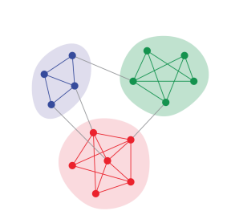
the total number of nodes is |V | diagram. A simple visualization of graph community structures is shown below.

Figure 1.1, where nodes and des form a graph and different colors refer to different communities. It is easy to see that there are three communities marked with different colors (blue, green, red). Within each community, the nodes are strongly connected, while there are few edges between them.

Background
The term “social network” was developed by John Barnes (Serret,2017) in 1954. According to Jacob Morenos “the roots of social network analysis invention of sociometry" was developed in 1934. According to (J Carrington and Scotts, 2011:1), they state that the concept of social networking has been around since the 1930s, but it was under the research of social network analysis (SNA) discovered in the early 1980s and 1990s social science field space (Wetheral,1998). This report will also research how SNA can be used to detect changes in social groups and communities online, including the impact on the economy. In 2021 a study by Andrew N. Mason found that after COVID-19 was declared, a pandemic consumers increased their users of social media to gather more research on different products such as evaluating product benefits, sell products, and express their level of satisfaction to their customers. According to (Statista, 2022) the market research industry has grown more advanced since 2008, which concludes that more searches have grown gradually. In previous last 5 years back, social media users have increased by over 1.52 billion to 4.59 billion people (Statista, 2023) increasing the number of publicity available to social network data on the internet. Through network visualization, they are tools used such as NodeXL and Gephi, applications of SNA.

Research Problem
The primary problem we face with SNA is data gathering. huge data sets with millions of nodes may also be too large for a single computer to manage, necessitating more processing power than is available, which can result in missing data and hence incomplete or incorrect analysis (Kumar, Geetha, & Kumar, 2018). Another issue with SNA is that it can be a time-consuming method.
1.3 Research Objectives
1. Explain how social network analysis can be used to track changes in brand communities.
2. Discuss the significance of employing social network research to influence modern social media marketing tactics, particularly the impact of economic instability.
3. Discuss the limitations of social network analysis in comprehending the brand community.
4. Which algorithms around social networking work better to detect the community per individual in a set.
5. What will be the balance between the communities and the number of modularity?

AIM
To examine the importance of using social media marketing in detecting the relationship of communities per individual. Social network algorithms will be used to inform modern social media marketing strategies and understand brand communities, also considering the implications of economic uncertainty for marketing managers on the internet.

  - Hypothesis
We hypothesize that the during of time the graph will increase over time, which indicates that more communities will be created in areas using social media. According to our analysis, we hypothesize that the Clustering Algorithm will perform better and faster result than the other Algorithm given.
1.6 Significance of the Research
This report will revise online social networks, or OSNs, that have become increasingly popular on the Internet. Examples of OSNs are Facebook, LinkedIn, Instagram, Twitter, and YouTube. As a result, additional OSN-based research questions utilizing SNA techniques are put forth. The primary cause is to find the ability to create and crawl massive datasets posted by many people through user interaction and information exchange (for example, 684,478 pieces of material are posted on Facebook, and Instagram on average every minute on the internet). According to Mark Zuckerberg and other social media peers they state that they are gambling their future on the assumption that corporations and organizations will spend large sums of money on advertisements in media.

LITERATURE REVIEW
This report has three groups, "Social media detection communities,” “Applications of social network analysis" based on the goals of the study of community detection. Numerous applications of SNA are described in the literature for social media marketing as well as other fields like network algorithm, and community analysis. A significant body of study in social media marketing has concentrated an opinion leaders and community detection. This research is conducted using the MMU library database and Google Scholar, this research is found under the topic of community detection in social media analysis. This research will focus on the COVID-19 impact during the pandemic and after the pandemic to predict how many communities were created during quarantine and after. A thorough review of academic papers, books, and articles on community detection methods, with a specific focus on their relevance to social network analysis (Iliho and Saritha, 2018). To be able to find the quality of communities, our literature measures the modularity (MOD), is one of the most valuable measures that is proposed by Newman and Girvan (2004) for the quality of communities. Emphasis will be placed on understanding the strengths and limitations of different algorithms. According to Yuan He has proposed a model called SILDA and its purpose is to form a group of people interest tweet collections but due to lack of information we will focus on the algorithms of communities in social media.

METHODOLOGY

3.1 Dataset
This research will look at the real-world dataset of people who were using social media during the pandemic of COVID-19, on how much communities have grown before the pandemic and after the quarantine in the period of 2018 to 2023. The data will be collected using NodeXL for the use of SNA graphs. The data that we will use will be found at, https://zenodo.org/records/4148941.

3.1.2 Data processing

Import Datasets

Data pre-processing

Community Detection Algorithm
Girvan-Newman Algorithm
Louvain Algorithm
Spectral Clustering

Graph Representation

Detect Communities

Molarity of each communities algorithm

Choose best Algorithm work better

3.2 Data analysis
We will use the three-algorithm given above to predict the communities and analysis for a period. Tools we going to use are Python language(SciPy and matplotlib.py) and NetworkX to help us predict and conclude which methods work better and to discover how much the world has evolved in social analysis.
3.2.1 Method of Community Detection Algorithms and Mathematical
Background
1. Girvan-Newman Algorithm: According to Newman and Girvan they discover a community detection of hierarchical in 2002. This algorithm always starts with an original graph then after it removes in between every time. According to Yang et al, the time of Girvan and Newman is O ($E^{2}*N$). The Girvan-Newman algorithm shows that it contains more time and is unable to provide results on time.
2. Louvain Algorithm: The Louvain method, introduced by Blondel et al. (2008), is a fast and efficient algorithm for detecting communities by optimizing modularity. It has been widely used in various real-world network analysis applications.
3. Spectral Clustering: Spectral clustering algorithms, as outlined by Von Luxburg (2007), leverage the eigenvalues of the network's adjacency matrix to partition the nodes into communities based on spectral embeddings. The method has a graph as Laplacian (L = D- A) where the value L is the eigenvalue and eigenvector of the matrix D is a matrix of a diagonal degree and A is the matrix adjacency.
3.2.2 Measurement of analysis:
Modularity: Modularity is a crucial statistic that shows when networks have structure, or when communities are present. According to Newman (2006), the measure of modularity is the number of edges within groups less the number that would be predicted in a network with randomly arranged edges.
Degree centrality: The quantity of linkages that a node has connected to it. Two measurements are specified for directed networks, such this one: in-degree and out-degree (Sharma and Surolia, 2013). This is the main matrix used in networks to identify nodes that are significant.
Eigenvalue Centrality: calculates the influence of a node in a network. A node is more central if it is connected to many nodes who are central
Betweenness centrality: This metric counts the instances in which a node is traversed by the network's lowest-cost paths. It gauges an individual's contribution to the flow of information inside a network from one point to another state by Golbeck (2015).
Python
In addition to NetworkX, we will use Python and associated libraries extensively in this research, as it allows for quick manipulation and analysis of data in a variety of formats. I am familiar with SciPy, NumPy, matplotlib, and several other packages. I have produced several useful libraries as well as collected several functions written by others (some of which I'll modify) that are very useful and are available in a library called python_lib.
Conclusion
This methodology will outline a systematic approach to community detection in social media, that will provide data collection, network representation, algorithmic techniques, and evaluation methods. By leveraging the referenced algorithms, researchers and practitioners can effectively uncover and analyse communities within social media networks the goal for this report is to find which algorithm works better

RESULTS AND DISCUSSION
Figure 1.1 Social platform student use during covid 12

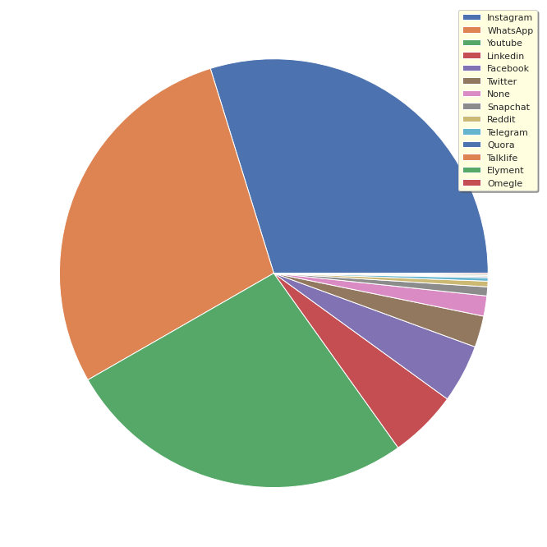

Figure 1.2 The communities that used social media from 2004 to 2018
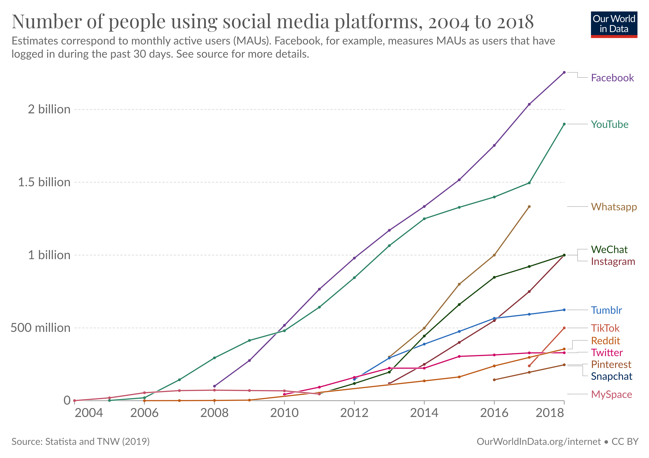
In this result this indicate that the more people create friend it indicates that the more the edges are created in each of the individual this prove that the SNA analysis shows that soon the social media will connect everyone around the world.
Figure 1.3 Statical Output of communities during covid 19
number | Statistics | Output
1 | Number of nodes | 19305
2 | Number of edges | 58060
3 | Average Degree | 1800
4 | Molarity | 0.435
5 | Number of communities created | 2515
Figure 1.4 Graph of Girvan- Newman Algorithm of student during covid
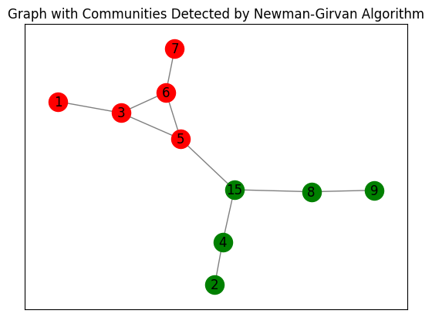
Modularity: 0.395
The Girvan-Newman algorithm's modularity score, which stands at 0.395, reveals how strongly the network is divided into communities. A modularity score of 0.395 indicates a moderate to good partition of the network, however results can vary according on the algorithm parameters and the characteristics of the network.
In conclusion, a modularity score of 0.395 suggests a decent partition of the network into communities for the network and the parameters employed with the Girvan-Newman algorithm, but there may be potential for improvement in terms of optimizing the community detection. More trial-and-error experimenting with various parameters or algorithms might produce better outcomes.

Figure 1.5 Graph of Louvain Algorithm
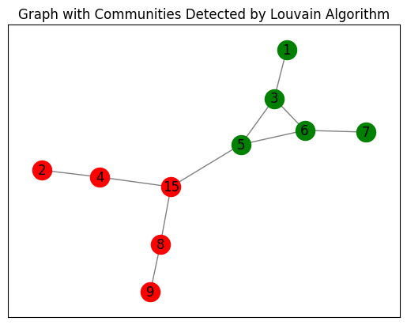
Modularity: 0.395
The modularity of the Louvain Algorithm, which detects communities in social media, is 0.395. The relative density of edges within communities as opposed to edges across communities is measured using a metric called modularity. Within the social media network, a moderate degree of community structure is indicated by a modularity value of 0.395. This value indicates that meaningful communities inside the network, with linkages within communities denser than would be predicted by chance, have been successfully discovered by the algorithm.
The Louvain Algorithm's modularity value of 0.395 shows that nodes have been successfully categorized into communities that are less related to nodes in other communities but have strong internal connections

Figure 1.6 Centrality Measures
Nodes | Degree Centrality | Closeness Centrality | Betweenness Centrality | Eigenvector Centrality
1 | 0.111111 | 0.31034 | 0.0 | 0.1941
2 | 0.111111 | 0.29032 | 0.0 | 0.06602
3 | 0.333333 | 0.4285 | 0.222222 | 0.4833
4 | 0.222222 | 0.39131 | 0.222222 | 0.16439
5 | 0.333333 | 0.529411 | 0.55555 | 0.52609
6 | 0.333333 | 0.42857 | 0.22222 | 0.48333
7 | 0.111111 | 0.310344 | 0.0 | 0.194107
8 | 0.222222 | 0.39130 | 0.22222 | 0.16439
9 | 0.111111 | 0.290322 | 0.0 | 0.06602059
15 | 0.333333 | 0.529411 | 0.66666 | 0.343319

Figure 1.6 Graph of Clustering Algorithm
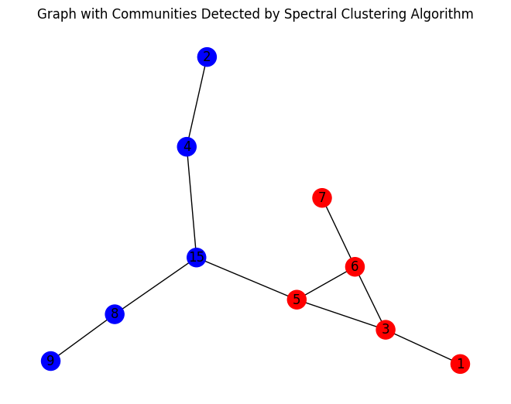
Modularity: 0.0992
A comparatively low degree of community structure inside the network is shown by the modularity of spectral clustering, which has a value of 0.0992. This implies that the network's unique communities have not been successfully detected by the algorithm, and that the node-to-node connections are not highly concentrated inside groups.
A strong community structure is generally indicated by modularity values that are closer to 1, whereas weak or random communities are indicated by values that are closer to 0. A rating of 0.0992 is seen as having a moderate level of community structure because it is less than the average modularity value of 0.4.
This low modularity score suggests that significant communities within the network have probably not been successfully recognized by the Spectral clustering algorithm.

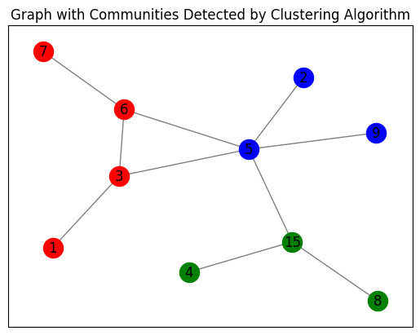
Modularity: 0.355
Community detection algorithm | modularity criteria
Girvan-Newman Algorithm | 0.395
Louvain Algorithm | 0.395
Spectral Clustering | 0.0992
CONCLUSION
According to our problem statement we have use all the method and we find that the Louvain Algorithm, with a modularity of 0.395, outperforms both Spectral Clustering and the Girvan-Newman Algorithm in terms of community detection, according to the modularity values presented. This is as a result of the Louvain Algorithm achieving a greater modularity value, which shows that the network's community structure is stronger. With a modularity of 0.395, the Girvan-Newman Algorithm recognizes communities as well, if not more so than the Louvain Algorithm. The algorithm's notable feature is its capacity to detect communities through edge betweenness centrality, a gauge of an edge's significance in linking disparate segments of the network.
Comparing Spectral Clustering to the Girvan-Newman Algorithm and the Louvain Algorithm, the modularity value of 0.0992 is substantially lower. This shows that Spectral Clustering is not able to locate communities inside the network efficiently, which may be because of the algorithm's parameter selection or its inability to handle huge datasets.
In summary, the Girvan-Newman Algorithm, Spectral Clustering, and Louvain Algorithm are the best techniques for community detection in this case. We conclude that our prediction has been oppose and indicate that the spectral clustering is not always the best algorithm to predict the communities between individuals.

APPENDITURE
import networkx as nx

# Given social media data
social_media_data = [
(1, 3), (6, 3), (2, 4), (15, 4), (15, 5), (5, 6), (5, 3), (6, 7), (15, 8), (8, 9)
]

# Create a graph from the data
G = nx.Graph()
G.add_edges_from(social_media_data)

# Compute the eigenvector centrality for each node
eigenvector_centrality = nx.eigenvector_centrality(G)

# Print the eigenvector centrality for each node
for node, centrality in eigenvector_centrality.items():
print(f"Node {node}: Eigenvector Centrality = {centrality}")

import networkx as nx
import matplotlib.pyplot as plt
from networkx.algorithms.community import girvan_newman
from networkx.algorithms.community.quality import modularity

# Given social media data
social_media_data = [
(1, 3), (6, 3), (2, 4), (15, 4), (15, 5), (5, 6), (5, 3), (6, 7), (15, 8), (8, 9)
]

# Create a graph from the data
G = nx.Graph()
G.add_edges_from(social_media_data)

# Apply Newman-Girvan algorithm for community detection
communities_generator = girvan_newman(G)
communities = next(communities_generator)

# Calculate modularity
mod = modularity(G, communities)
print("Modularity:", mod)

# Plot the graph with color-coded communities
pos = nx.spring_layout(G) # Position nodes using Fruchterman-Reingold force-directed algorithm
colors = ['r', 'g', 'b', 'y', 'c', 'm'] # Define colors for up to 6 communities
for i, community in enumerate(communities):
nx.draw_networkx_nodes(G, pos, nodelist=community, node_color=colors[i], node_size=300)
nx.draw_networkx_edges(G, pos, alpha=0.5)
nx.draw_networkx_labels(G, pos, font_size=12)
plt.title('Graph with Communities Detected by Newman-Girvan Algorithm')
plt.show()

4. REFERENCES
Alotaibi, N. and Rhouma, D., 2022. A review on community structures detection in time evolving social networks. Journal of King Saud University-Computer and Information Sciences, 34(8), pp.5646-5662.
Blei, D. M., Ng, A. Y., & Jordan, M. I. (2003) 'Latent Dirichlet Allocation', Journal of Machine Learning Research, 3, 993-1022
Blondel, V. D., Guillaume, J. L., Lambiotte, R., & Lefebvre, E. (2008) 'Fast unfolding of communities in large networks', Journal of Statistical Mechanics: Theory and Experiment, 2008(10), P10008
Cao, C., Ni, Q., & Zhai, Y. (2015). An Improved Collaborative Filtering Recommendation Algorithm Based on Community Detection in Social Networks. In Proceedings of the 2015 on Genetic and Evolutionary Computation Conference. ACM, 1-8. doi:10.1145/2739480.2754670.
Qi, G.J., Aggarwal, C.C. and Huang, T., 2012, April. Community detection with edge content in social media networks. In 2012 IEEE 28th International conference on data engineering (pp. 534-545). IEEE.
Newman, M. E., & Girvan, M. (2004) 'Finding and evaluating community structure in networks', Physical Review E, 69(2), 026113.
Holland, P. W., Laskey, K. B., & Leinhardt, S. (1983). Stochastic block models: First steps. Social Networks, 5, 109–137.
Raghavan, U. N., Albert, R., & Kumara, S. (2007). Near linear time algorithm to detect community structures in large-scale networks. Physical Review E, 76(3), 036106.
Xie, J., Kelley, S., Szymanski, B. K., & Overlapping community detection in networks: The state-of-the-art and comparative study. ACM Computing Surveys (CSUR), 45(4), 43.

